**INSTRUCTIONS from GPG 16-1**

**i. Facilities, Equipment and Other Resources**

This section of the proposal is used to assess the adequacy of the resources available to perform the effort proposed to satisfy both the Intellectual Merit and Broader Impacts review criteria. Proposers should describe only those resources that are directly applicable. Proposers should include an aggregated description of the internal and external resources (both physical and personnel) that the organization and its collaborators will provide to the project, should it be funded. Such information must be provided in this section, in lieu of other parts of the proposal (e.g., budget justification, project description). The description should be narrative in nature and must not include any quantifiable financial information. Reviewers will evaluate the information during the merit review process and the cognizant NSF Program Officer will review it for programmatic and technical sufficiency.

Although these resources are not considered cost sharing as defined in 2 CFR § 200.306, the Foundation does expect that the resources identified in the Facilities, Equipment, and Other Resources section will be provided, or made available, should the proposal be funded. AAG Chapter II.B.1 specifies procedures for use by the awardee when there are postaward changes to objectives, scope or methods/procedures.

**CHECKLIST from GPG 16-1**

**Facilities, Equipment and Other Resources:**

[ ] An aggregated description of the internal and external resources (both physical and personnel) that the organization and its collaborators will provide to the project, should it be funded, has been included.

[ ] No quantifiable financial information has been provided.

[ ] If there are no facilities, equipment or other resources identified, a statement to that effect has been included in this section of the proposal and uploaded into FastLane.

**Facilities, Equipment, and Other Resources**

The proposed research effort will benefit from multifunctional shared spaces as well as state-of-the-art equipment, instrumentation, and computation and laboratory facilities that exist within Columbia University and the Data Science Institute.

**Data Science Institute (DSI):**

The Data Science Institute is housed within 44,000 square feet of multifunctional space at Columbia University. This space includes faculty offices, conference rooms, student work stations and collaborative meeting spaces, all designed to promote a collegial and interactive physical community around data science and to encourage interdisciplinary approaches to research training. See Figures 1 through 7 below. The Institute also has support staff to assist with the financial management of the project, as well as the educational and outreach activities associated with the project.

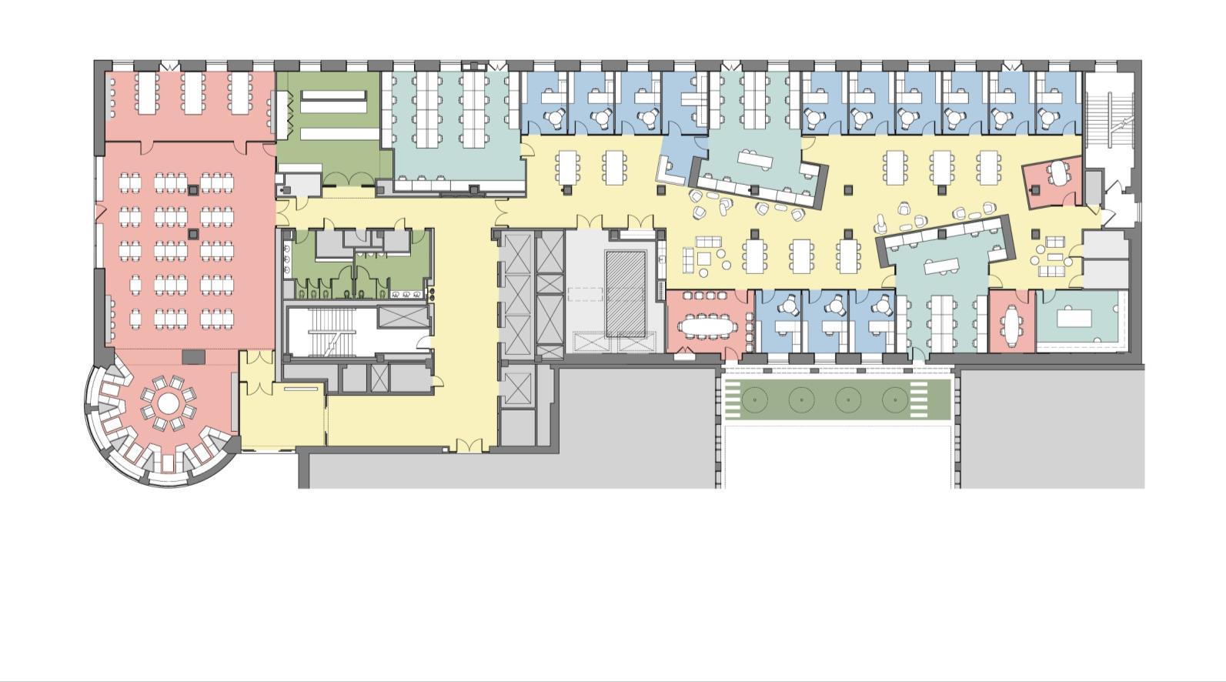

Figure : MUDD 400 Carleton Lounge and Data Science Institute

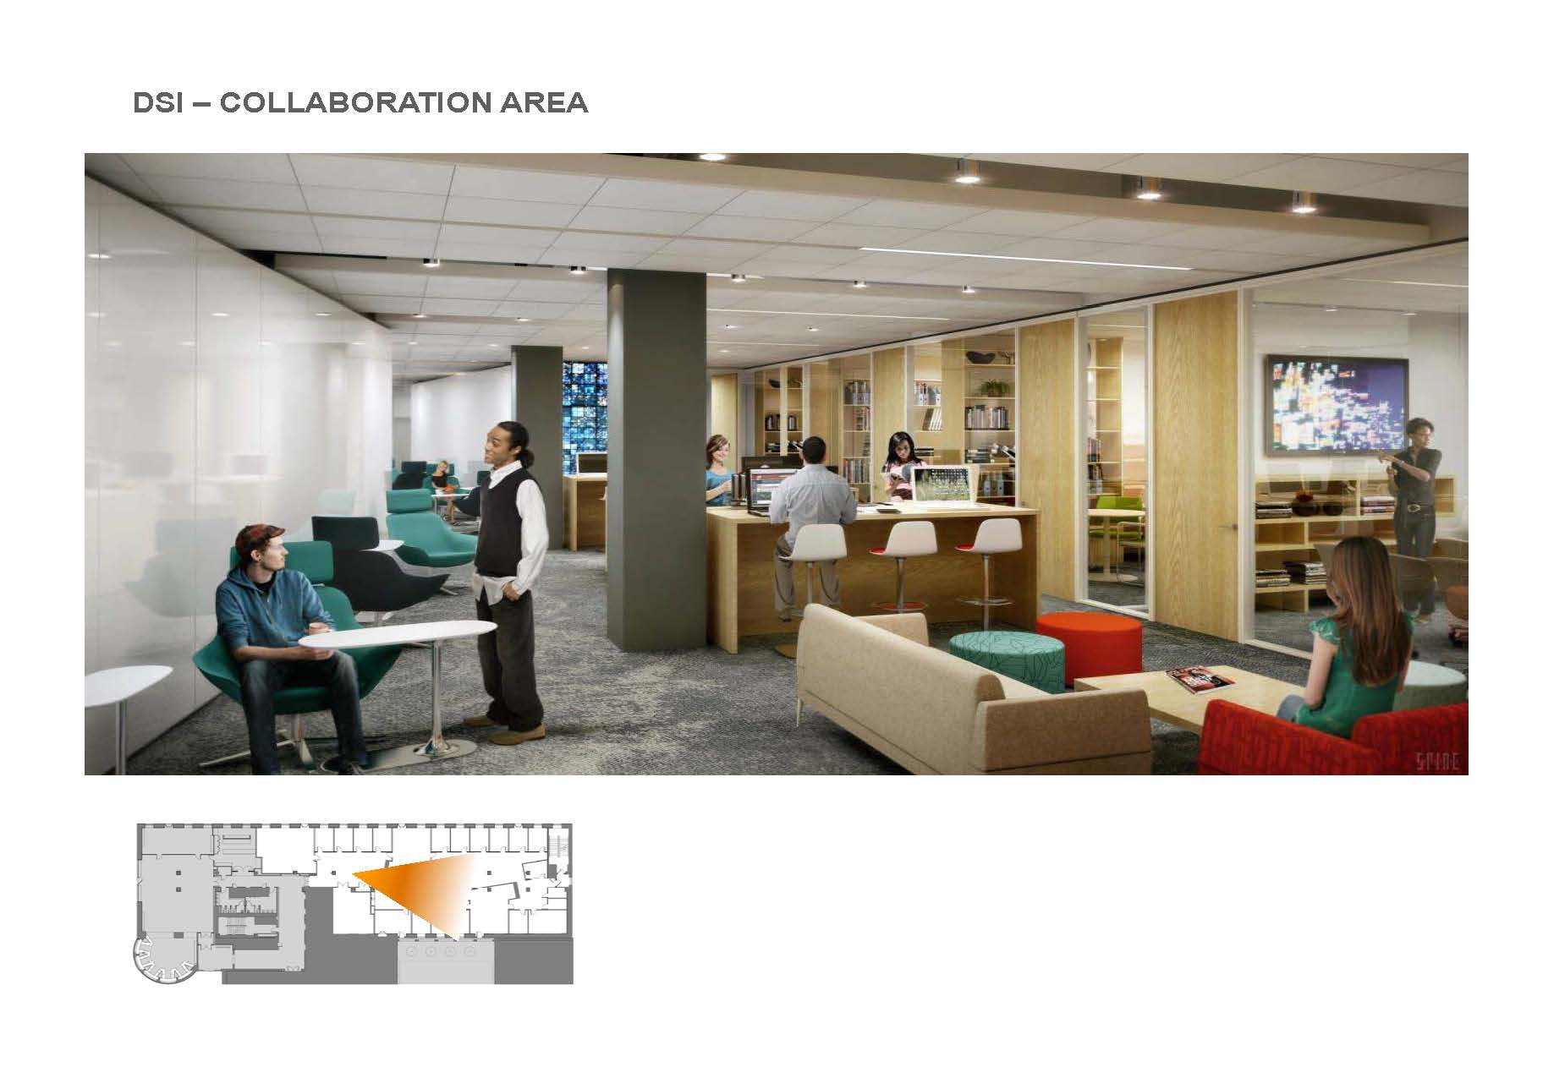

Figure : Data Science Institute Collaboration Area

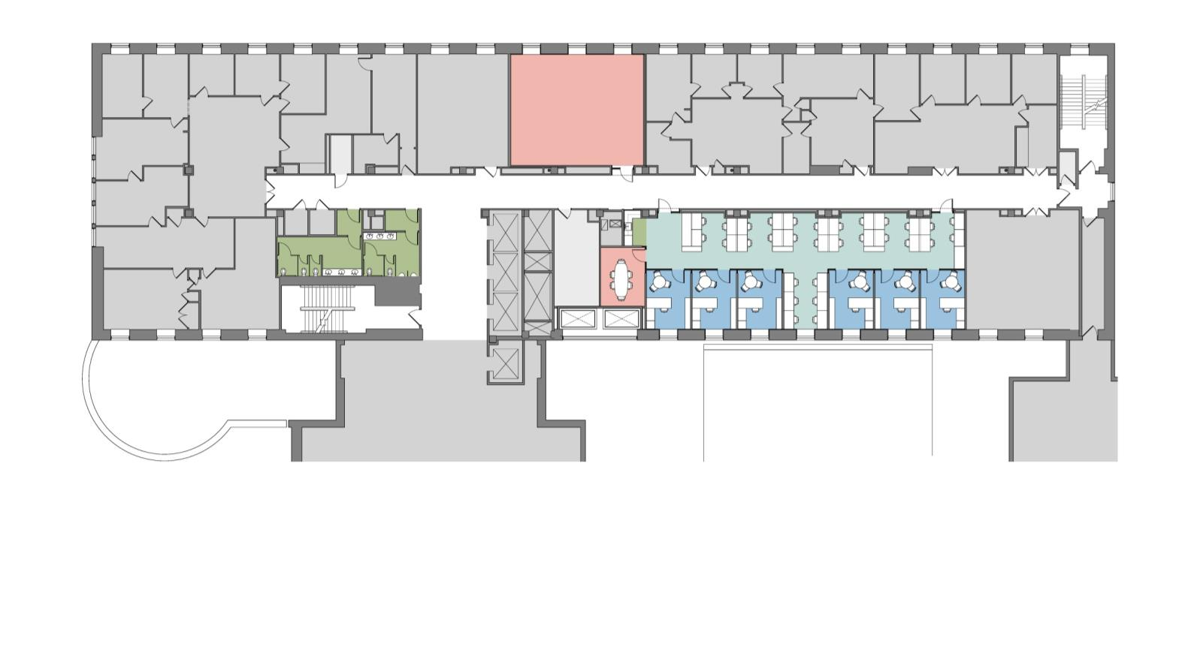

Figure . MUDD 500 Data Science Institute

DSI faculty have access to *Yeti*, a High Performance Computing (HPC) Cluster housed in Columbia’s centrally-managed Shared Research Computing Facility (SRCF), which consists of a dedicated portion of the university data center.  The total server count is 167 execute servers with a total of 2762 computer cores. The CPU on all expansion machines is the 2.6 GHz E5-2650v2.

Additionally, the Institute acquired from Yahoo! 40 HP compute servers to be used to support Institute research projects. These machines are configured with HP DL160 G5 2 x L5420 CPUs, 16GB of RAM and 1 x 1 TB 7.2K SATA Disk.

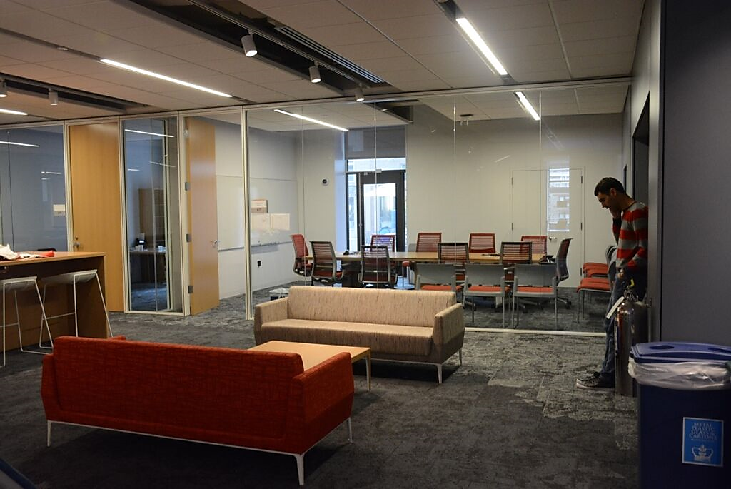Shared storage is available through a Network Appliance storage file server.

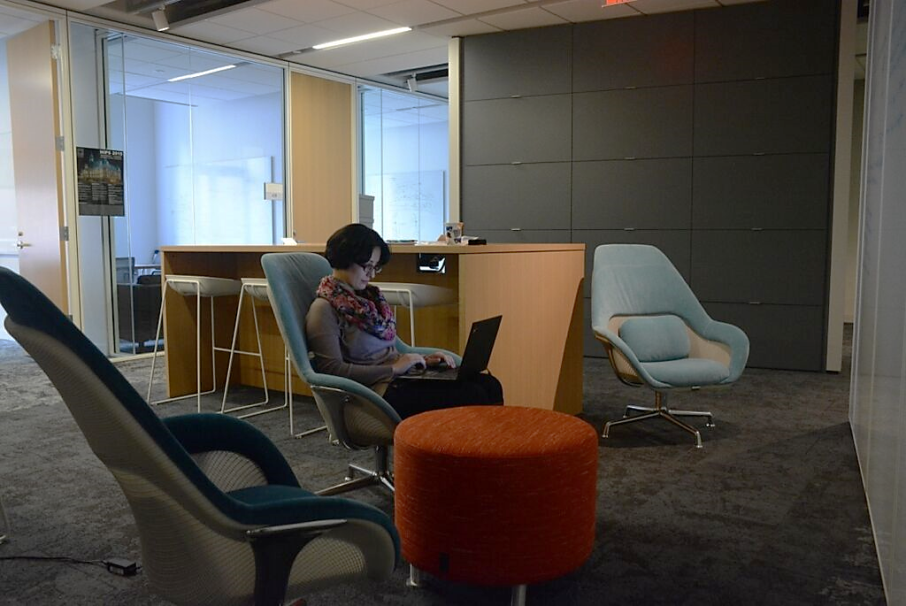

Figure 5: DSI Collaboration Area and Conference Room

Figure 4: DSI Collaboration Area

**Columbia University Information Technology** maintains Columbia's commodity Internet connections that include 1 Gb/s via Level 3, 5 Gb/s via Cogent and 100 Mb/s via RCN (for RCN residential cable modem customers). Columbia's research and education network connections include a NYSERNet NYC and statewide regional optical network ("dark fiber"), a 1 Gb/s connection to NYSERNet's IP network and from there to

Internet2 and National Lambda Rail (NLR) packet net and 1 Gb/s connection to the US

Large Hadron Collider Network (USLHCNET) providing connectivity to CERN.

The research infrastructure includes many Sun, Dell and HP servers and hundreds of workstations from Apple, Dell, HP and other PC manufacturers. The labs for research in image processing, vision, graphics, and robotics contain such specialized equipment as a

Data Cube image processor, an Adept1 robot, and Aspex PIPE (an eight-stage parallel, pipelined, low-level image processor), Unimate Puma 500 and IBM robotic arms, a Utah-

MIT dextrous hand, high performance 3-D graphics workstations, 3-D position/orientation trackers, see-through headworn displays, and a wall-sized stereo display.

CRF facilities are partially supported by the Secure Cyber Operations and Parallelization

Studies (SCOPS) instrumentation grant from AFOSR (Contract #: FA 99500910389).

**Technical Support**

The research facilities are staffed by professional systems engineers who are responsible for operating system and network support, miscellaneous hardware and software maintenance, and troubleshooting. These staff members allow individual researchers to avoid spending time on hardware and software problems.

Specific sections below to be completed, as needed.

**Laboratory:**

**Clinical:**

**Animal:**

**Computer:**

**Office:**

**Other Resources:**

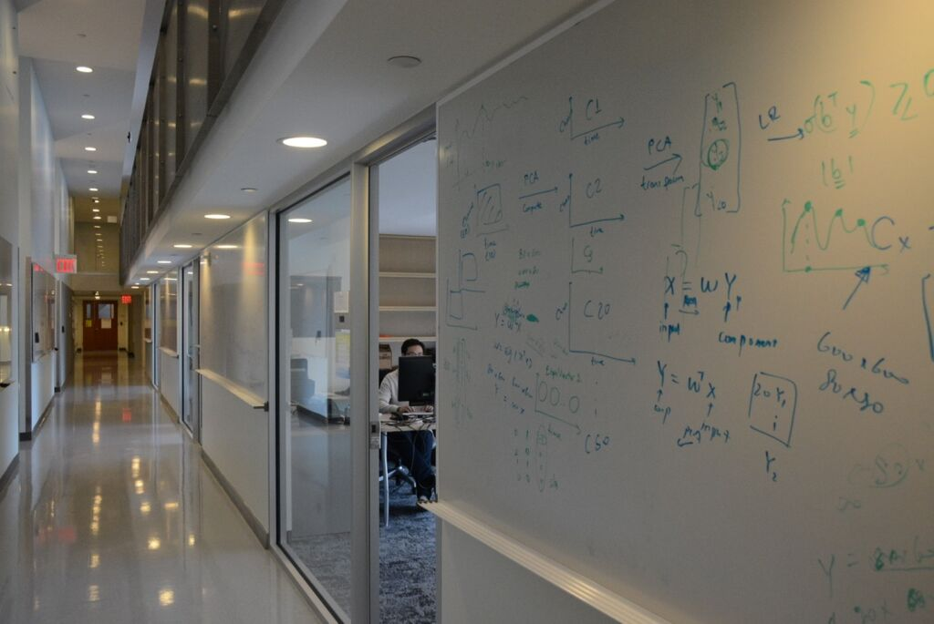

Figure 6: Northwest Corner 10   
Data Science Institute Faculty Offices and Labs

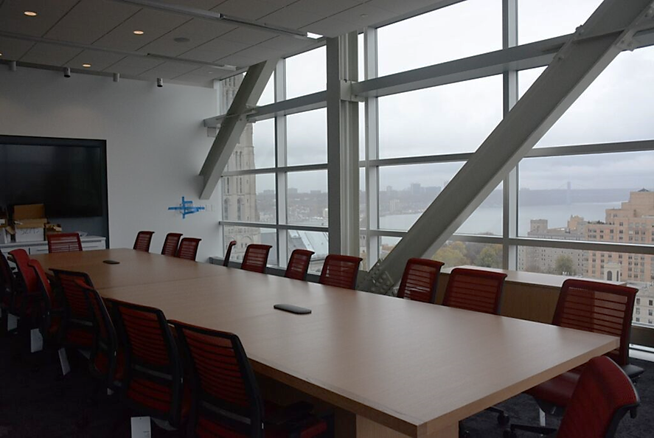

Figure 7: Northwest Corner 14 Conference Room